1. Introduction to ESE 5410
▶️ Course Introduction (8:40)
[MUSIC] Welcome to the course is statistics for that assigns my name is Victor Preciado and I will be the lecture in this course let me start by telling you a little bit about my background. I have a PhD in electrical engineering and computer science from MIT where I worked on stochastic modeling of large complex networks and currently I'm a professor in the Department of electrical, and systems engineering at the University of Pennsylvania.
Data science is a very popular topic nowadays. However, many data science courses focus on presenting a list of machine learning techniques without providing a deeper understanding of the statistical foundations of these techniques.
In this direction, this course will not focus on programming or implementation, for which you can find excellent courses online, but on developing an understanding about why, how and when some of these learning techniques work from a statistical perspective.
I believe this is of upmost importance for both software engineers implementing code as well as managers making decisions based on data.
On the one hand, choosing the right learning technique to implement in your code must be based on an understanding of the tool you're implementing, instead of blindly trying different alternatives. On the other hand, those making decisions from data must understand the scope and limitations of the techniques used to digest this data in order to make informed and valuable decisions.
Although we will cover some implementation details throughout this course, our focus will be on developing a theoretical understanding of data science tools using statistics and learning theory. Without much delay, let me show you some concrete topics to be covered in this course.
Let me mention a few words about data science, so data science is about drawing useful conclusions from large and diverse data sets through three phases, which I described here as exploration, prediction and inference. In the exploration phase, we try to identify patterns that are useful in our analysis using visualization and descriptive statistics.
In a second phase, which I call prediction, we use information to make informed guesses about values we wish we knew using machine learning and other tools in our third phase called inference. We quantify the degree of certainty or uncertainty in our models. In other words, we try to answer the question, how accurate are our predictions? The main tools in this third phase are statistical tests and models.
In this course we will see how it statistics is a central component in data science because it studies how to make robust conclusions based on incomplete information, and this will be the focus of this course.
Let me add a few words about data driven learning. We can find two different approaches to explain reality. A model based approach, which is a classical approach based on deriving models of a system based on 1st principles such as Newton's law for physical systems, relativity or optics. In contrast, we can also use a data driven approach. This data driven approach is useful when dealing with many complex modern systems in which it's not possible to explain their behavior from first principles. Think for example of the stock market, human behavior, or the brain. These systems are so complex that we don't have the Newton slow equivalent. In order to make a model of the revolution in this situation, however, we can still make useful predictions using data science. In practice, we will see that the best approach is to combine both model based and data driven approaches.
In the following slides I will show you a few examples of data driven problems.
The first example involves the identification of digits in a handwritten zip code. You can take a look at the figure in this slide. These are digits represented by 16 by 16 grayscale images. And the problem would be to automatically identify the digit that is represented by each one of these pictures. This problem, however, it's very hard to solve using first principles. It would be very hard to come up with an explicit computer program able to decipher what character is represented in the picture just by looking at the pixels in this image. However, using machine learning we can come up with a black box with many parameters that we can train using input output samples. In a second example, we consider the problem of predicting the salary of an individual using demographic variables. You can see in this figure how the demographic variables are age, year and the education level. The problem would be to use these three inputs. These three demographic variables to predict what's the salary of the individual presenting this real features.
This is again a problem that's hard to solve using first principles and we would consider as an alternative a data driven approach in which we will train a machine learning architecture to make predictions about salary.
As a third example, we consider the problem of voice recognition. In this example, we have two phonemes. That sound like out and old, and we represent the power spectral density of the recording representing these phonemes. The question in here is to try to code a computer program able to recognize a particular phoneme using the sound signal or the power spectral density. This is again a hard problem in a much more efficient way to go around it is to use machine and statistical learning techniques.
In here we have another example involving the recognition of land usage using satellite data. In here we have four images representing different imagery, using four different spectral bands, and our problem would be to identify land usage based on this four images. You should find a classifier able to tell you if particular piece of land correspond to red soil, gray soil, vegetation, cotton and so on and so forth. In here we can compare the actual land usage with the predicted land usage based on a machine learning algorithm.
Another example involves the identification of risk factors in heart disease. In this particular problem, we're given a data set containing a collection of individuals with and without heart disease. As well as their obesity level, alcohol consumption, and their age, and the problem in consideration is to find which one of these three factors have a stronger influence in the probability of each individual's developing heart disease.
A final example we can consider is to try to identify the role of mobility in COVID-19 transmission or any other epidemic transmission that takes place in society. In here we take as Inputs the mobility of the population that we can retrieve from Google Maps. In particular, Google Maps provides some community mobility reports that allow us to quantify how much individuals are moving through different areas of a city.
Our objective would be to try to re late this mobility patterns with the time evolution of infections deaths, an hospitalized due to COVID-19. This is again our problem that cannot be solved using first principles and we need to rely on data driven techniques.

▶️ Course Administration (5:47)
Let me start by covering a set of topics that we will go over throughout this course. These are roughly the main chapters of this book, An Introduction to Statistical Learning, that is available online for free, and we'll make a link in the website of the course. In here, you have a list of the main topics to cover in the course. We'll start with an introduction of statistical learning. We'll go in more depth detail about what statistical learning really is. We'll move on to linear regression, which I know most of you should know, but it's a very simple setup in which many of the topics in this course can be simply introduced. Then we'll move on to classification, in which we try to take an input and assign a label to the output. So you can think of this as an example of classifying pictures online containing dogs and cats. Then we'll move on to resampling methods, which is a very useful statistical technique to quantify the uncertainty for models. Then we'll move on to model selection and regularization. The last three chapters will be on tree-based methods, support vector machine, and unsupervised learning. All the topics mentioned in the previous slide can be classified using two families of learning problems. The first family is what's called supervised learning. In a supervised learning problem, we are given a training data set D. Inside this data set, we have a collection of N pairs. Each pair, x_i and y_i, represents two elements. The first element, x_i, is a p-dimensional input. A p-dimensional input is nothing but a collection of features that we can use to classify the input. So think of, for example, if this is an image, x_i can be a collection of the pixels. If it's a voice recording, would be the voice signal or some features about this voice signals such as the power spectral density and so on and so forth. The variable y_i is what's called the outcome or the output, also called response target or dependent variable. This y_i is typically either a value or a label that we want to assign to the input x_i. In practice, we want to find a function able to map inputs to outcome variables. As I mentioned before, the outcome variable can be of two types. If y_i is a quantitative variable, we say that the problem is called a regression problem, think of quantitative variables such as salary. In contrast, the outcome can be a qualitative variable. In that case, the problem is called a classification problem. By qualitative variables, I'm talking about a variable that can only take a value within a finite set, for example, images of dogs and cats. So some examples of these problems are digit recognition. In that case, the outcome is one out of 10 possible outcome values, a finite set of values, meaning a qualitative variable. In that case, the problem of digit recognition would be a classification problem. We also have the problem of a speech recognition and image classification. These three particular problems are classification problems. But if you want to predict a numerical value such as the salary of a particular individual, that problem would be a regression problem. Apart from supervised learning, we also have unsupervised learning problems. In this type of problems, we are given a collection of inputs alone. So instead of pairs, as we had before, we're only given the inputs x_1-x_N. Our problem is to find groups of variables that behaves similarly. For example, any clustering problem in which we are not given labeled data would be an unsupervised learning problem. These are some of the prerequisites and workload for this course. The necessary skills that you need are basic programming, preferably Python, although any other language that you know should be valid for this course. We also need a solid undergraduate background on probability. If you also have linear algebra, that's also a welcome skill. The workload describes how your weekly work should look like. First, you will have to watch a series of videos with some theoretical content and relate related sections from the ISL book. ISL is short for Introduction to Statistical Learning, which is the book I mentioned before. Then you should solve some graded assessment questions that will be a major part of your grade. At the end of each chapter, we will also provide you with a video connecting the contents of a section with some Python code. Once we present you with this Python code, you should solve some graded coding assignments in the form of Python projects. I want to mention a quick note in here which is, this is not a coding course, although we will use Python to introduce some of the concepts covered in the course. In any case, we will provide you with the tools to transition from whatever language you have been using before to Python. Before you move on to the next video, I suggest that you read Chapter 1 from the book An Introduction to Statistical Learning. After you're done reading this chapter, you can move on to the next series of videos in which we provide a review of Probability Theory. Probability Theory will be a key component of this course, and I strongly suggest that you go through these videos carefully. I will see you in the next video.

1 Attempt Quiz: Introduction

2. Introduction to Module 1
▶️ Welcome to Module 1 (0:41)
In the next series of videos, I will provide you with a review of probability theory. Probability theory is a very important part of this course and I strongly suggest you go through these videos carefully. However, remember that probability theory is a prerequisite to this course, and the intention of these videos is not to substitute a course in probability theory, but provide you with a review of probability theory.

3. Probability Review
▶️ Elements of Probability (7:52)
So let's move on to the elements of probability, as you probably know there are three basic elements in probability theory. We have a sample space omega, which is the set of all possible outcomes of an experiment. On top of that sample space we can define a set of events f, we also have a probability measure that maps an event from the set f into a real number, so this is intuitively the probability of the event. We have three properties for this probability function, the first property is that this function is always non negative, we also have the that the probability of the whole space of outcomes is equal to 1. And the third property is that if we have two events, A1 or A2 that are disjoint, then the probability of their union is equal to the sum of the probabilities. So let's consider the case of tossing a dice with six sides, the sample space in this case is the possible outcomes which are 1 to 6. A possible choice for F is the set of all subsets of omega, so these subsets can include the odd numbers or the even numbers or the set 1,2,3, the set 4,5,6 and so on and so forth. Now we have that the probability of the outcome omega being in a set A, an event is given by the cardinality of that event divided by 6. For example, if you can see that the event of the outcome of the dice V in an even number, you know that the even numbers could be 2, 4 and 6. The cardinality of that set is 3, and three divided by 6 is one half, which is what you would expect the probability of getting an odd number or an even number to be. Let's continue by looking into some extra properties of this probability functions. The next property states that the probability of the intersection of two sets A and B, is less or equal than the minimum between the probability of A and the probability of B. The second property states that the probability of the union is less or equal than the sum of the probabilities, probability of A and probability of B. And the third property states,that if A1 to Ak are a partition of omega, then the sum of the probability of this sets is equal to 1. If you can't remember these properties, there is a very convenient visual way, to prove them using areas. For example, you can consider a set that we represent here as a square of unit area therefore the area inside the square is going to be area 1, this set is going to represent our sample space omega. So any subset in omega represents an event for example, this ellipsoid in here can be the event A, and the area inside the ellipsoid would represent the probability of A. You can take two sets,A and B and convince yourself that the area inside these sets satisfy the properties that we have on the left. After introducing the basic elements of probability and some of their properties, we can move on to more sophisticated definitions. The first one is a definition of conditional probability and independence, we define the conditional probability of any event A, given an event B, has the following fraction. So in the numerator, we're going to have the probability of the intersection of A and B. And normalizing this probability in the denominator, we're going to have the probability of B. So the resulting fraction is what we call the conditional probability, that we denote by the probability of A vertical bar B. In plain words, what this probability represents is the probability of the event A after observing the occurrence of the event B. You can also very easily find an interpretation by looking at the Venn diagram above, so the numerator of probability of A Intersection B is nothing but the area in this set, and the probability of P is going to be the area inside this green ellipse. We can also define the notion of independence, so we say that two events are called independent if and only if, the probability of the intersection is equal to the product of their probabilities. You can easily prove that this definition is equivalent, that probability of a conditional B is equal to the probability of A. So intuitively what this last expression tells you, is that the probability of A, doesn't change after B has happened. And the proof of this last expression, as I mentioned before is extremely easy. So you can start with the probability of A conditional B, you can use the definition that you have in here, and write it as a fraction of probability of A intersection B, divided by the probability of B. Now using independence, you can plug the intersection as the product probability of A times probability of B, divided by the probability of B. Now you see that these two terms cancel resulting in, the probability of A which is exactly what this last statement is indicating. We now continue our revision of probability theory, by looking into random variables, the mathematical definition of a random variable, is a function x, that maps elements from the sample of space, into real numbers. For example, for an outcome omega in the sample space, we typically denote the random variable, using uppercase letters X of omega or simply X, if the omega is understood from the context. As it's typical in many textbooks, we denote the realization that the random variable may take using lowercase letters x. Let's look at an example in which I toss three different coins at once, when you throw three coins, the sample space is all the combinations of H and T when H represent heads, and T represent tails. So in here you're going to have HHH meaning all the coins come out head HHT meaning the first two come out head and the third come out tail, and so on and so forth. We define the random variable H of omega as the number of heads, in one of these random outcomes omega. So you can think visually of the set omega as the set containing all the outcomes of the experiment mean HHH, so this will be one element of the sample space, you're going to have HHT, another element of the sample space, so on and so forth and the TTT now. A function X will take one element, omega, so this is what we call a small omega, and we'll map it into a real number. In this particular case, H of omega, is going to be the number of heads, which in this case will be 2. So essentially, it's just a function that takes elements in the sample space, omega and maps a real numbers.

1 Attempt Quiz: Elements of Probability

1. 機率的三大公理與性質
機率必須符合三個基本規則（由數學家 Kolmogorov 提出）：
- 非負性：任何事件的機率不能是負的。
- 單位性：整個樣本空間 $\Omega$ 發生的機率必須等於 1。
- 可加性：如果兩個事件 $A$ 和 $B$ 互斥（沒有交集），那麼「$A$ 或 $B$ 發生」的機率就是兩者相加。
例子:
1. 樣本空間 Omega = {1, 2,….., 6}
- 定義：樣本空間（Omega）是指一個實驗中所有可能結果的集合。
- 解釋：當你擲一顆六面骰子時，結果只可能是 1, 2, 3, 4, 5, 或 6。所以這個集合包含了這 6 個元素。
2. 事件集合 F} 是 Omega 的所有子集 (Power Set)
- 定義：在機率論中，我們感興趣的「事件」通常是樣本空間的一個子集。
- 解釋：F 代表所有你「可以問的問題」的集合。
  - 例如：你可能想問「結果是不是偶數？」，這對應的集合是 {2, 4, 6}
  - 例如：你可能想問「結果是不是大於 4？」，這對應的集合是 {5, 6}
- 「所有子集」的意思：包含空集 emptyset（不可能發生的事）、單一結果（如 {1}）、到整個 Omega（一定會發生的事）。對於只有 6 個元素的 Omega，總共有 2^6 = 64 種可能的事件。
3. 機率計算 P(A) = |A|/6
這是一個公式，用來計算某個事件 $A$ 發生的機率：
- |A| (Cardinality)：這是指集合 A 裡面的元素個數。
- 6：這是樣本空間 $\Omega$ 的總元素個數。
舉例說明：
假設事件 A 是「擲出偶數」，那麼：
- A = {2, 4, 6}
- |A| = 3（裡面有三個數字）
- 機率 P(A) = 3/6 = 0.5 (也就是 50%)

💡 進階性質（視覺化證明）：
你可以把機率想像成「面積」。假設整個正方形面積是 $1$：
- 交集小於等於任一事件：P(A \cap B) ≤ min(P(A), P(B))。因為交集（重疊部分）不可能比原本的任何一個圓圈大。
- 聯集小於等於機率之和：P(A U B) ≤ P(A) + P(B)。這就是所謂的「連通不等式」，因為重疊的部分在相加時被算了兩次。
- 分割（Partition）：如果一堆事件 A_1,…., A_k 像拼圖一樣剛好填滿 Omega 且不重疊，它們的機率總和必為 1。

2. 條件機率與獨立性 (Independence)
這是這段話最實用的部分。
條件機率公式：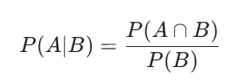
- 白話解釋：在「已知 B 發生」的前提下，A 發生的機率。
- 視覺化：你的世界原本是整個正方形，現在縮小到只有 B 這個圓圈。在 B 的範圍內，A 佔了多少比例？
獨立性：
- 定義：如果 P(A \cap B) = P(A) x P(B)，我們稱 $A, B$ 獨立。
- 直觀意義：P(A|B) = P(A)。這代表「即使我知道 B 發生了，對我預測 A 的機率完全沒有影響」。就像今天下雨（事件 B）不會影響你投籃投進（事件 A）的機率。
- 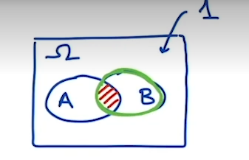

3. 隨機變數 (Random Variable, R.V.)
這是很多人會卡關的地方，但其實它就是一個 「翻譯機」：
- 定義：一個將「實驗結果（omega）」對應到「實數（Real numbers）」的函數。
- 標記習慣：
  - 大寫 X：指這個「函數」（隨機變數本身）。
  - 小寫 x：指某一次實驗觀察到的具體數值（實現值，Realization）。
範例：丟三次硬幣
- 樣本空間 Omega：有 8 種可能，如 {HHH, HHT, ….., TTT}。
- 隨機變數 H(omega)：我們定義 H 為「出現人頭的次數」。
- 運作方式：
  - 如果結果 omega 是 HHT，那麼 H(HHT) = 2。
  - 如果結果 omega 是 TTT，那麼 H(TTT) = 0。
這個函數把「文字敘述的結果」變成了「可以計算的數字」，這樣我們才能算平均值、變異數等統計量。

💡 學習小建議
你目前在看這段教材，通常是為了後續進入 隨機過程（Stochastic Processes） 或 機器學習中的機率模型。這段內容強調了：
- Venn Diagram (韋恩圖) 是理解機率性質最強大的工具。
- 條件機率 是所有貝葉斯推論（Bayesian Inference）的基礎。
- 隨機變數 是把現實世界數據化（Digitize）的第一步。

▶️ Probability Distributions (3:20)
Once we have defined the concept of random variables, we can move on to the concept of the distribution of a random variable. Our first definition is going to be the cumulative distribution function, which we'll denote by CDF, and it's defined as the probability of a random variable capital X being less or equal than x. We're going to denote that using the capital letter F. So to clarify what capital X and a small x means, you can consider an example where the set Omega is the set of all individuals in society. So these are going to be people in the US, for example. Capital X is going to be a random variable that map an individual to a number. So we can, for example, use income for this random variable, and a small x will be a particular value of the income. For example, something like a 100K, so it's not a bad income. So F of X_x in this particular case would be F_income of a 100K, and what this value would represent is essentially the probability that a particular random individual has an income less or equal than a 100K. Now, for continuous random variables, we can define the probability density function that we denote as PDF as the derivative of the CDF with respect to x, and we're going to use the small f to denote the PDF. Using this definition, you can easily prove that the probability of X being in a particular set A is equal to the integral of the PDF over the set A. For example, in the case of income, if you consider the different values of income in here, and you can see there is set A, something like this interval, what you're going to get is a function F_income of x, such that the integral of the function, in this interval A, would represent the probability that a random individual in society has an income between these two values in here. Apart from continuous random variables, we can also deal with discrete random variables. So these are functions x of Omega that map into a discrete set of values. For example, you can consider the set of natural numbers, the set of integer numbers, and so on and so forth. A particular example of a discrete random variable would be to throw a dice. You can define a random variable X, which is the outcome of a dice, and this would be a random variable in which the values would be in the set 1-6. For discrete random variables, we can define the probability mass function, which we denote as PMF, as the probability that the particular random variable capital X takes a value of small x. So if capital X is a dice, small x will be a value 1, 2 up to 6, and the probability will be equal to one-sixth for all those values.

1 Attempt Quiz: Probability Distributions

這段內容將「隨機變數」進一步延伸到如何描述它們的機率分佈。這裡介紹了三個最核心的工具：CDF、PDF 和 PMF。

1. 累積分佈函數 (CDF, Cumulative Distribution Function)
這是最通用的工具，不論是連續還是離散變數都適用。
- 數學定義：F_{X}(x) = P(X ≤ x)
- 白話解釋：數值「小於或等於某個值」的總機率。
- 你的範例（收入）：
  - Omega：全美國的人。
  - X：某人的年收入（隨機變數）。
  - x：100K（具體數值）。
  - F_{income}(100K)：代表「隨機抽一個人，他的收入低於或等於 100K」的機率。
2. 連續隨機變數：PDF (Probability Density Function)
當變數是連續的（例如收入、身高、電池壽命），我們用「密度」來描述。
- 數學定義：（CDF 的導數）。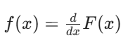
- 核心特性：積分
  - 要算 X 落在某個區間 A（例如收入 80K 到 120K 之間）的機率，就對 PDF 做積分：
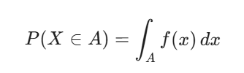
- 直觀理解：PDF 圖形下方的面積就是機率。PDF 在某個點的值很大，代表隨機變數很有可能出現在那個點附近。
3. 離散隨機變數：PMF (Probability Mass Function)
當結果是可以一個一個數出來的（例如擲骰子、硬幣次數、人數），我們用「質量」來描述。
- 數學定義：p(x) = P(X = x)
- 你的範例（擲骰子）：
  - X 的可能取值是 {1, 2, 3, 4, 5, 6}。
  - P(X=1) = 1/6，P(X=2) = 1/6 ….. 這些具體的機率值就是 PMF。
- 區別：連續變數在「某一點」的機率通常是 0（所以才需要積分算區間）；但離散變數在「某一點」是有具體機率值的。

📊 快速對比表
特性 | 累積分佈函數 (CDF) | 機率密度函數 (PDF) | 機率質量函數 (PMF)
符號 | F(x) | f(x) | p(x)
適用對象 | 所有人 | 連續變數 (如：收入) | 離散變數 (如：骰子)
定義 | P(X ≤ x) | F(x) 的變動率 | P(X = x)
機率計算方式 | 直接看數值 | 算曲線下的面積 (積分) | 直接把數值相加
💡 學習筆記 (針對你目前的專業背景)
- 工業應用：在電池製造中，如果你在預測「電池失效時間」，失效時間是一個連續變數，你會用到 PDF；如果你在統計「一批產品中的不良品數量」，這是一個離散變數，你會用到 PMF。
- CDF 的妙用：在做數據分析時，CDF 非常適合用來觀察「百分位數」。例如：你想知道 90% 的電池壽命都大於多少小時，直接看 F(x) = 0.9 對應的 x 即可。
這段教材是為了之後講期望值 (Expectation) 和 變異數 (Variance) 做鋪墊，因為那些公式都會用到這裡定義的 f(x) 或 p(x)。

▶️ Expectation and Variance (8:33)
Once we have defined random variables under distributions, we can define more sophisticated mathematical objects, such as the expectation. So we start with the expectation of a discrete random variable x with a PMF p of X. So the expectation is going to be the expectation of a function g, which is going to map real numbers into real numbers and the expectation of g of X is defined as indicated below. So in the rest of the course, we're going to use this fancy E to represent the expectation of whatever is inside this bracket. Inside this bracket, we have the random variable X use as the argument of the function g and in the right hand side, we have a summation. This summation is the product of the function g of X times the probability of the PMF p of x. And this summation is for all the values X in this set, fancy X and this fancy X represents the set of all possible values that X may take. So to fully understand what this expectation is, we can take a simple example. So think of the case of X being the throw of a dice and the function g could be something like the squared function. So g of x is something like x squared. So this is a function that map's real numbers into real numbers. Now we can look at the expectation of v of X. So remember the argument in here is the capital X, which is the throw of a dice. This is going to be equal to the expectation of X squared. So it's essentially the value of the dice squared and obtain the definition this is going to be the summation for x in fancy X of g of x, meaning x square times p of x, and we know that the p of x is equal to 1/6 for all possible outcomes of the dice, right? Now, remember with this axis, this x is the values that the dice can take and this is nothing but the set 1, 2, up to 6. So, this expression is going to boil down to compute this very simple summation, so x from 1 to 6 of x squared times 1/6. And the result of this summation is a concrete number. This particular case is going to be 91 divided by 6 which is roughly 15.16 when x is a continuous PDF, the expected value of the function g of x can be written in terms of an integral. So in this particular case, we're going to have an integral that expands all possible real numbers meaning from minus infinity to infinity of g of x times the PDF. So notice how the expression is very similar to the expectation in the discrete case. In particular, we substitute the summation by an integral sign, g of x remains the same, and the PMF p of x becomes the PDF f of x.
Now there is a particular case of importance, which is when the function g(x) is just identity function. In this particular case, the expectation E[g(X)] = E[X], and this is called the mean of the random variable X. After cleaning things up, I can now move on to the properties of the expectation. The first property is the following. If we have a constant value a real value, we have that the expectation of a real value is the real value itself. You can think of this property as follows.
A constant value a can be thought as a PMF In which the whole mass of the distribution is concentrated on a. In other words, the probability of a is equal to 1 and the probability of any other value different than a is equal to 0. If you apply the definition of the expectation on this particular PMF you can easily prove the quality that I have in here. Also if I compute the expectation of A times A function g of x, it turns out that this a can come out of the expectation as a multiplicative factor. So the expectation of a times g of x is equal to a times the expectation of g of x. In other words, the expectation it's a homogeneous operator. The second property most the summation of two functions, f of x and g of x, it turns out that the expectation of the sum is equal to the sum of the expectations. So these two properties put together is telling us that the expectation is a linear operator.
Now we move on to the definition of the variance of a random variable. The variance of x is defined as indicated in this expression. So essentially, the variance is the expectation of x minus the mean of x, all that squared. So notice that x is a random variable, but E of X is a concrete number. So every time you compute the expectation of a random variable, you get a number a constant and you can treat this whole E of X as a constant in your operations. You can very simply prove through some simple manipulations that the evidence can also be written as the expectation of X squared minus the expectation of X, all of that is squared. Okay, so this is just, again, a constant number squared and this is the expectation of the function X squared. The variance presents some interesting properties. So, if we consider a constant a, a real value, when we multiply the function g by this constant value a, the variance is multiplied by the square of a(X). In other words, if we want to take out a out of the variance, we need to put a square on the value of a. We also have another interesting property involved in independent random variables. Say we have two random variables X and Y that are independent. We know that the variance of the sum is equal to the sum of the variances. So this is something that occurs only when X and Y are independent random variables. So let's move on into a simple example. So let's compute the mean and the variance of a random variable with a uniform PDF in the interval 01. So this PDF according to the definition in here, is says follows. So the random variable x in the interval 0, 1 will take the value 1 and 0 otherwise. So you're going to get a big function that takes the value 1 in this middle interval and 0 outside. So this is the PDF. Now we can use the PDF to compute the mean and the variance. So the mean of f of x, if you use the definition we had before, this is going to be the interval from minus infinity to infinity of x dx. Now, the integral from minus infinity to infinity is reduced to the integral between 0 and 1 because the function f of x takes a value 0 outside that interval. So if you compute this integral, you get a value of 1/2 which is what you would expect essentially the mean of this random variable to be in the middle point of this density function. You can very similarly compute the expectation of x squared by applying the definition of the expectation of a function. So the expectation of a function is equal to the function time the PDF which in this particular case is 1 times dx in the interval minus infinity to infinity. But again, the interval of interest in here is going to be 0 to 1 because I would say that interval the function takes about the value 0. If you compute this integral, you get a value of 1/3. Now you can compute the variance has the expectation of x squared, which is 1/3 minus the expectation of x to the square which is 1/2 to the square equal to 1/4. You put these two pieces together and you compute a variance for the uniform distribution to be equal to 1/12.

1 Attempt Quiz: Expectation and Variance

這段內容討論了機率論中兩個非常重要的統計量：期望值 (Expectation) 與 變異數 (Variance)。它們分別代表了數據的「中心點」與「離散程度」。
我為你整理了核心公式與重點邏輯，這對你處理電池製造中的數據分析或機器學習模型非常有幫助。

1. 期望值 (Expectation / Mean)
期望值可以看作是加權平均數。
- 離散型 (Discrete)：使用加總 (sum)
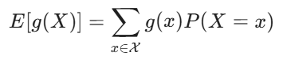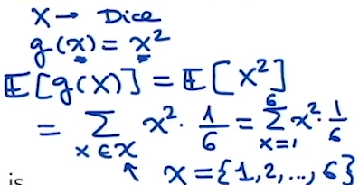
- 連續型 (Continuous)：使用積分 (int)
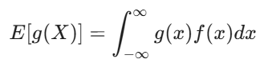
重要性質：線性 (Linearity)
期望值是一個線性算子，這意味著：
- 常數不變：E[a] = a
- 常數可提出：E[aX] = aE[X]
- 可加性：E[X + Y] = E[X] + E[Y] (不論 X, Y 是否獨立都成立)

2. 變異數 (Variance)
變異數衡量數據偏離平均值的程度。
- 定義公式：Var(X) = E[(X - (E[X]))²]
注意: X是隨機變數 但E[X]是一個數值
- 常用計算公式：Var(X) = E[X²] - (E[X])²
(白話記法：平方的期望值 減去 期望值的平方)
重要性質：
- 常數平方倍：Var(aX) = a² Var(X) (因為差值平方了，所以常數也平方)
- 獨立加法：如果 X, Y 獨立，則 Var(X + Y) = Var(X) + Var(Y)。

3. 範例拆解：均勻分佈 (Uniform Distribution)
教材中舉了 U(0, 1) 的例子，這非常經典：
- PDF: 在 0 到 1 之間 f(x)=1，其餘為 0。
- 平均值 (Mean):
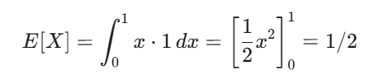
- 平方的期望值:
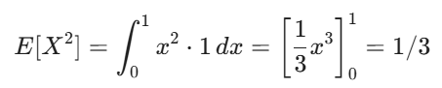
- 變異數 (Variance):
Var(X) = 1/3 - (1/2)^2 = 1/3 - 1/4 = 1/12

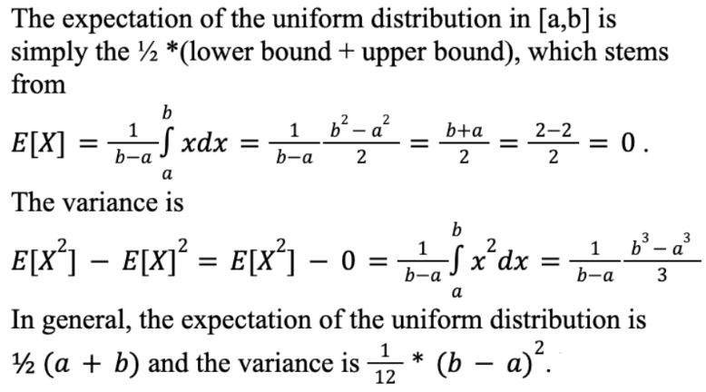

💡 给你的專業連結
在你的電池製造（Lithium-ion Battery）領域中：
- 期望值：通常代表製程的「目標值」。例如，你希望塗佈（Coating）的厚度平均值維持在某個微米數。
- 變異數：代表「品質的穩定性」。變異數越大，代表製程波動（Manufacturing bottleneck）越劇烈。在優化混合循環時間（Mixing cycle time）時，你追求的不只是平均時間的降低，通常也希望降低變異數，以確保每批次的一致性。

▶️ Common Distributions (4:30)
I'm going to look into some common distributions that you should be familiar with. We're going to start with some discrete random variables, meaning random variables that take values in a discrete set. There are two important cases, the Bernoulli random variable, and the binomial random variable. So starting with the Bernoulli random variable, we are going to denote that the random variable X is distributed according to a Bernoulli random variable using the notation in here, where p is a parameter that describes the PMF. So you can think of Bernoulli random variables as flipping a coin. Essentially, you flip a biased coin, where the probability of the coin turning out heads is equal to p. So this p doesn't have to be one-half. Therefore, the probability of getting tails is one minus p. Now, this random variable maps the outcome head to a value x equal to 1. In other words, the probability of getting x equal to one is going to be equal to p, and if the coin turns out to be tails we'll get a value of x equal to 0. So the probability of x being equal to 0 is equal to 1 minus p. So this is simply explained by plotting the PMF. So we're going to have two possible discrete values which are x equal to 0, and x equal to 1. The probability of getting one is going to be p, just a positive value between zero and one, and the probability of getting a zero is going to be 1 minus p. So these bars indicate the probability of each one of these events in here. So this would be the very simple graphical way to represent the PMF corresponding to the Bernoulli random variable. Another important discrete random variable is the binomial random variable that we denote using Bin (n, p). So here we have two parameters instead of one, and the binomial random variable is related with flipping n coins with a bias p. So think of the following experiment. You take n coins, all of them have a bias p. Now, flip all these coins at once, you flip them simultaneously, and then count the total number of heads that you're getting here. So call that number h. So the probability that you get h heads after flipping n coins with a bias b is represented by this expression in here. So notice that the three parameters you have in here is how many coins you flip, what are the bias of these coins, and how many heads you obtain? Apart from discrete random variables, we can also deal with continuous random variables. So there are two particular PDFs that are very important. The first one is the uniform PDF, that we represent as Unif (a, b). So a and b are just two real numbers. So let me plot here the real line. So we're going to have two real numbers a and b, and the uniform distribution between a and b is going to be essentially a brick function, brick PDF. There's going to take a value zero outside the interval a b, and in the interval a b it's going to take a value such that the area under this PDF is equal to 1. So you can very simply find out that this function has to be equal to 1 divided by b minus a in order for the area of that brick to be equal to 1, and this is exactly what we indicate in this part of the definition of this function. So it's one over b minus a for x in the interval and zero outside the interval. We can also define the normal, also called the Gaussian distribution, that many of you are probably familiar with using the notation n Mu Sigma squared. So Mu represents the mean of the Gaussian PDF and Sigma squared is the variance. This is the explicit expression of a Gaussian PDF. So if you plot this function, what you obtain is a bell-shaped function where the highest value is at the mean Mu, and then how spread this bell is, is going to be proportional to Sigma, the standard deviation, the square root of the variance.

1 Attempt Quiz: Common Distributions
這段教材介紹了機率論中最常見的四種分佈：兩種離散型（白話：可以數出來的）和兩種連續型（白話：連續不間斷的數值）。

1. 離散型隨機變數 (Discrete R.V.)
白努利分佈 Bernoulli (p)
- 場景：單次實驗。只有兩種結果（成功/失敗、頭/字、過關/掛科）。
- 參數：p（成功的機率）。
- PMF：
  - P(X=1) = p
  - P(X=0) = 1-p
- 例子：投一次不公平的硬幣。
二項分佈 Binomial (n, p)
- 場景：多次獨立的白努利實驗。
- 定義：投 n 次硬幣，總共出現 h 次人頭的機率。
- 參數：n（次數）、p（單次成功的機率）。
- 公式：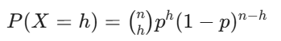
  - binom{n}{h} 是組合數，代表從 n 次中挑出 h 次成功的排列方式。

2. 連續型隨機變數 (Continuous R.V.)
均勻分佈 Unif (a, b)
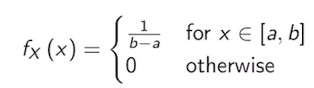
- 場景：在區間 [a, b] 內，每個點出現的「機會」都一樣。
- PDF 高度：1/b-a（為了讓矩形總面積等於 1）。

常態分佈 / 高斯分佈 Normal (µ, σ²)
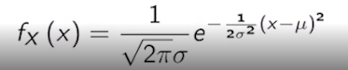
- 場景：自然界最常見的分佈（如身高、測量誤差、電池容量的微小波動）。
- 參數：
  - µ (Mean)：鐘形曲線的中心點。
  - σ² (Variance)：曲線的寬度（σ 越大，鐘形越扁平）。
- 特點：對稱於 µ，且大部分的數值都會落在 [µ-3σ, µ+3σ] 之間（即 99.7% 法則）。

💡 連結你的專業背景
作為 鋰電池工程師，這些分佈在你的工作中非常實用：
- Bernoulli/Binomial：可用於品質檢測。例如，檢測一批電芯是否合格。如果單顆不合格率是 p，抽檢 n 顆中出現 h 顆次級品的機率就是二項分佈。
- Normal (Gaussian)：這對你的 Slurry Rheology（漿料流變學） 或 Coating（塗佈） 過程至關重要。
  - 例如：塗佈厚度的控制。你希望厚度分佈是一個均值 µ為目標值、且 σ非常小的常態分佈。
  - 如果 σ過大，代表製程不穩定，會導致電池一致性下降。
- Uniform：通常用於描述「完全不確定」的情況，或是某些物理參數在特定容差範圍內的隨機偏差。
這段內容是為了讓你理解，當我們拿到數據時，我們會先假設它符合某種「模型（分佈）」，然後才進行後續的統計推論。

4. Multivariate Probability
▶️ Two Random Variables (10:26)
We're going to start this video by considering two random variables that we denoted here by X and Y. So when we consider two random variables, we can have different distributions that we can use. The first one is the joint CDF, the cumulative density function. So we're going to denote the joint CDF as capital F of X and Y, and the definition is very similar to the CDF of a single random variable. In this particular case, if we have random variables X and Y, the CDF evaluated at x y, small cases, is going to be the probability that capital X is less or equal than small x and capital Y is less or equal than small y. So to get an illustration of what the joint CDF means in two dimensions, we consider the case where X is, for example, the income of a particular individual in society, and Y is age. So now we can essentially evaluate the joint CDF for particular values of a small x and a small y. So it is considered that the small x is an income of 100K, and small y is something like 30 years old. So what F of x, y evaluated at 100K, 30 years old, what that means is the probability that you pick an individual at random in society, and both his income is less or equal than 100K, and his age is less or equal than 50 years old. We can also define a joint PDF, in this case, instead of having a first order derivative, we're going to have a second order derivative, essentially, it's going to be the second order partial derivative with respect to x and y. This definition is not very practical, something that's more important and more useful is the interpretation of the probability of the two variables X and Y to be joint in a particular set A. This set A is going to be a two-dimensional set. Now, this probability using the joint PDF can be computed using a double integral where x and y are evaluated in that set A. In the case of dealing with two discrete random variables, we can define a joint PMF. This joint PMF is going to be nothing but the probability that one discrete random variable take a discrete value x, the small x, and another discrete random variable, capital Y takes a discrete value y. So you can think of X and Y as for example, flipping a dice so that would be the outcome of the random variable X, and maybe the random variable Y could be the outcome of flipping a coin, where you'd get a one if the coin comes out head. So now, this joint PMF could describe the probability that the dice is, for example, three, and the coin comes out heads. An important concept when dealing with several random variables, is the concept of marginalization. Before we go into the particular equations that describe the mathematical marginalization process, you should think of the following scenarios, so imagine that you have a PDF describing the joint distribution of several random variables, so following on the previous examples, think that your random variables are both income and age, and you have the joint PDF. However, in certain cases, instead of being interested in the joint probability of having a particular age and a particular income, maybe you only care about income alone. So the process of marginalization will take you from a joint PDF describing the probability of age being a particular value and income being a particular value to only the probability that the income takes a concrete value. So going into the mathematical details of how to marginalize a density function, we're going to start with the CDF, the cumulative density function, so how do you marginalize a CDF? Well, just start with the joint CDF between X and Y, and now if you take the value of y and compute the limit for y going to infinity, the result would be a marginalization over X. Why? If you look at the definition of the joint CDF of X and Y, this is the probability that X is going to be less or equal than x and Y is going to be less or equal than y, but if you make y going to infinity, at the end of the day, it's like effectively removing the effect of this second variable, because everybody will have a value of y less or equal than infinity. If you take the case of X being equal to income, and Y being equal to age, if you make the limit of age going to infinity, in reality, what you're really evaluating is the total number of people with an income less or equal than x. You can also marginalize the PDF. In order to do that, we're going to take the joint PDF for X and Y, and perform an integral from minus infinity to infinity involving the variable Y alone. So in particular, what you're going to do is if X is income and Y is age, you're going to integrate over all possible ages, and that will result on the marginal probability of getting a particular value of the income. In the discrete case, we can define the marginal PMF and the marginalization process in a similar way as we did for the continuous PDF, and essentially what we do is we substitute the integral by a summation and instead of integrating over Y, we do a summation over all possible values of Y. So this fancy Y is the set of all values that Y can take. These three operations take a joint distribution, and project them, or map them into a single variable distribution. Another important operation is the conditioning operation. So the probability distribution of a random variable Y, given that you already know that the second random variable X takes an exact value as small X is described using the conditional distribution. So we can illustrate this concept using the conditional PMF. So if we have the joint PMF between two random variables, X and Y, the conditional probability of Y given X, is going to be equal to that joint PMF divided by the marginal P of X. So looking back into this equation, you can read that the joint PMF of X and Y, is by definition equal to the probability that X is equal to small X, Y is equal to Y and the marginal is given by this numerator. So this is going to be our notation for the probability of Y given X. Again, this is the probability that a second random variable Y takes a value given that the random variable X takes another value. So you can think of the example of income and age. So if X correspond to the income of a random individual chosen in society and Y is the age of these random individual? Then the conditional probability of Y given X for two particular values of X and Y can be interpreted as follows. So let's use the same values that we had been using before. So I'm going to pick X to be equal to an income of a 100,000 and I'm going to choose y as an age of 30-years-old. So the probability of Y given X, when Y is 30 years old and X is a 100,000 is the probability that out of all the individuals in society making a 100,000 a particular individual chosen at random from that pole is equal to 30-years-old. In other words, another way to compute this P of Y given X is to isolate from society all the individuals that are making a 100,000 and compute the fraction of individuals in that pool that are 30-years-old. That fraction would be equal to P of Y given X. Assuming that X and Y are continuous random variables, we can also define a conditional PDF and the definition is exactly the same as the one we had before. In this case, instead of having a joint PMF, we're going to have a joint PDF in the numerator and a marginal PDF in the denominator and instead of using the letter P for this probabilities, we're going to be used in the letter f. So this is going to be the notation that we're going to use for the conditional probability of Y given X. Again, this is the probability that Y takes the value y given that X takes a value X. When dealing with two random variables, we can also consider the concept of independence. So we say that two random variables are independent if knowing the value of one variable does not affect the conditional probability distribution of the other variable. So let's consider the case of two discrete random variables, X and y. Then we have that the two random variables being independent imply that the joint PDF, in this case, PMF is sub X, Y is equal to the product of the marginals BX and BY you can easily prove that this equality is the same as the conditional probability of X given Y being equal to the marginal probability PX and the conditional probability P of Y given X is equal to the marginal probability P, Y. In the continuous case, the equations hold the same, you just change the P for an F, meaning the symbol that we use for PMFs, for the symbol that we use for PDFs and everything else hold the same as before.
1 Attempt Quiz: Random Variables
這段內容探討了當我們同時考慮兩個隨機變數（雙變數分佈）時的運作邏輯。這在現實世界中非常重要，因為很少有事件是孤立發生的，比如「年齡與收入」、「塗佈速度與厚度」之間通常都存在關聯。
我將其核心概念拆解為三個關鍵層次：聯合 (Joint)、邊際 (Marginal) 與 條件 (Conditional)。

1. 聯合分佈 (Joint Distribution)：全局觀點
這描述了兩個事件同時發生的機率。
- CDF (F_{X,Y})：P(X ≤ x, Y ≤ y)。如X=income, Y=age
  - 例如：一個人的收入x低於 10 萬且年齡y小於 30 歲的機率。
- PDF (f_{x,y}) : 描述某個微小區域(連續)的機率密度
  - f_{x,y}(x,y) = $∂F_{XY}(x,y)/∂x∂y$
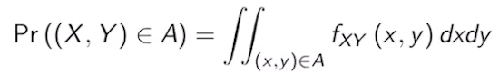
- PMF (p_{x,y})：描述在某個特定點(離散)的機率密度或機率值
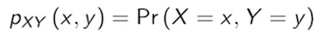
- 例如：X是dice, Y是coin. 一個dice投出3, coin投出人頭的機率。
- 為什麼機率密度函數 (PDF) 是 累積分佈函數 (CDF) 的微分，我們可以從它們的定義和「微積分基本定理」的角度來看：
- CDF F(x)：代表隨機變數 X 落在小於或等於 x 的區域的總累積機率。
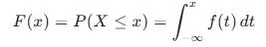
- 根據微積分基本定理，如果你定義一個函數為另一個函數的積分：
  - 若F(x) =$\int_{a}^{x}{(t)}$dt ，那麼對 F(x) 求導（微分）的結果就會是裡面的函數：$\frac{d}{dx}$ F(x) = f(x)
  - 這在數學上直接解釋了兩者的關係。
- 這就像物理學中「位移」與「速度」的關係：
  - CDF 像是「總位移」：記錄了從起點到現在時間點 x 總共走了多少距離（累積了多少機率）。

  - PDF 像是「瞬時速度」：在時間點 x 的那一瞬間，你走得多快（機率增加的速度有多快）。
  - 微分的本質是「變化率」。當我們問 F(x) 的微分是多少時，我們是在問：「當 x 增加一點點時，總機率增加了多少？」而這個增加的「速率」，正是機率密度 f(x)。

2. 邊際化 (Marginalization)：消除變數, 聚焦特定變數
當你擁有聯合數據，但只想關注其中一個變數時，就需要「邊際化」。
- 直觀理解：
  - 如果你有「收入」和「年齡」的交叉表格，將某一列或某一行的所有數值加總，得到的結果就是該變數的邊際機率。
  - 如果你想知道「所有人的收入分佈」，而不分年齡，你就需要把所有年齡層的收入機率加總或積分。
- 數學操作：
  - Marginal CDF:
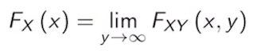
- X=income, Y=age, y趨近無窮表示: income< x的所有人都會被包入
  - Marginal PDF連續型：對 Y 軸進行全範圍積分(對一個變數進行積分)
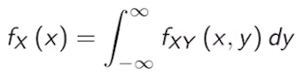
  - Marginal PMF離散型：將 Y 的所有可能取值加總(對一個變數進行加總)
p_{x} = Σ_{y} p_{x,y} (x,y)
- 目的：把二維分佈投影回一維分佈。
- CDF 技巧：讓其中一個變數趨近於無限大（例如 Y to infty），等同於包含該變數的所有可能性，進而得到另一個變數的邊際分佈。

3. 條件分佈 (Conditioning)：獲取新資訊
這是理解「因果」與「預測」的核心。描述了「在已知 X 的情況下，Y 的表現」。這在預測中至關重要。
- 公式：
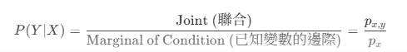
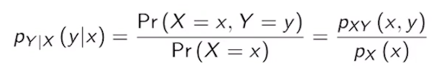
- 白話解釋：在所有年薪 10 萬(x= 100K)的人群中（縮小範圍），隨機選一人是 30 歲(y=30)的機率。

4. 獨立性 (Independence)：互不干涉
如果 X 的發生完全不會改變你對 Y 的預期，則兩者獨立。
- 如果 X 與 Y 獨立，則 P(Y|X) = P(Y)。這代表已知 X 的資訊對你預測 Y 完全沒有幫助。
- 判定標準：聯合機率等於邊際機率的乘積。
  - p_{x,y} (x,y)= p_{x} (x) p_{y}(y)
- 後果：如果獨立，則條件機率等於邊際機率 P(Y|X) = P(Y)。

💡 與專業連結 (Lithium-ion Battery Manufacturing)
在電池製程中，你可以這樣應用這些概念：
- 聯合分佈：考慮「漿料黏度 (Viscosity)」和「塗佈速度 (Coating Speed)」。
- 邊際分佈：儘管黏度會變，但你只關心在整個生產線中，塗佈速度的整體平均表現。
- 條件分佈：這是最關鍵的。 如果感測器顯示現在的「漿料黏度 (X)」是某個固定值，那麼「塗佈厚度 (Y)」的分佈會變嗎？
  - 如果 X 與 Y 獨立，黏度變了也不影響厚度（這在實務上不太可能）。
  - 如果 X 與 Y 相關（不獨立），你就能根據已知的黏度，計算出厚度偏離目標值的機率，進而自動調整參數。
- 獨立性檢定： 如果你發現「操作員姓名 (X)」與「缺陷分析率 (Y)」是獨立的，這是一件好事，代表你的自動化製程非常標準化，不受人為因素干擾。

▶️ Expectation and Covariance (4:54)
When dealing with two random variables, we can also define a notion of expectation and covariance, which is an extension of variance.
We have that the expected value of a function g is defined as we indicate below. One detail that you have to keep in mind is that, in this particular case, the function g takes two values, essentially points in R2, and map a real number R. So, in other words, a function g has two input arguments. So, if we look into the discrete case, we see that the expectation of the function g with the two arguments x and y, is equal to a double summation. So inside the summation what we have is the product of the function g times the joint pmf of x and y. And we evaluate this product over all the possible values of x and y. In the continuous case, we substitute the double summation by a double integral, but the idea is exactly the same. So if you look inside the integral, what we have is the function times the joint pdf. And now we evaluate the integral over all possible values of x and y.
We can also define the covariance of two random variables, which is a natural extension of the variance as I indicate below. So the covariance of X and Y is nothing but the expectation of the product of two terms. So we're going to have the product of X minus the mean of X times Y minus the mean of Y. So notice or remember that X and Y are random variables, but the expectations, meaning these means, have concrete numbers.
So this numbers behave specially when you take expectations. So using that fact, we can manipulate the expression and reach to the following expression, which is that the covariance of X and Y. Can be written as the expectation of the product of X and Y minus the product of the expectation of X times expectation of Y.
There is a particular case, which is when the covariance is equal to zero. In that particular case we say that the two random variables, X and Y, are uncorrelated. Something that's important for you to keep in mind is that this is different than being independent. So two random variables being uncorrelated does not imply that these random variables are independent. However, you can easily prove that two random variables being independent imply that they are uncorrelated.
Let's now move on to the concepts of conditional expectation and variance. These concepts will play an important role when we are studying statistical learning problems. We define the conditional expectation of Y given X as we indicate in the expression below. Notice that the expression that we have in here is exactly the same one that we use for the expectation of Y. The only thing that we are changing is adding this conditional part in both the expectation and the distribution. So to refresh your memory, we have that the expectation of Y is equal to the integral minus infinity to infinity of y times f of y evaluated at y, dy. So everything we are doing in here is to include in there, in there and in there, the conditional part of x. So we condition over x, condition over x, and here we condition a very small x, but the expressions are very close to each other. Notice that, after we solve this integral over y, what you obtain is a function that depends on x. In other words, what you're getting here is a function that depends on the particular value of x that you choose.
Similarly, we can define the conditional variance of Y given X in the same terms that we define the variance of Y. So, if you remember the variance of Y is defined as. An integral from minus infinity to infinity, of y minus the mean of y, squared, times the pdf of y evaluated at y, dy. So what we do in the expression below is essentially add the conditional part in here, in here, and in here. To modify everything that depends on y alone to a conditional version. Again, once you solve the integral over y, what you obtain is a function that depends only on x.

1 Attempt Quiz: Expectation and Covariance
這段教材介紹了雙隨機變數中的兩個核心統計量：期望值 (Expectation) 與 共變異數 (Covariance)，以及它們的條件形式。
1. 雙變數函數的期望值 (Expectation of a Function)
當隨機變數 X 與 Y 經由函數 g(X, Y) 映射至實數時，其期望值的計算邏輯與單變數相同，只是擴展為二維空間：
- 期望值 E[g(X, Y)] 是在問：「考慮到所有可能出現的 (x, y) 組合，函數 g 的平均表現是多少？」
- 離散型 (Discrete)：使用雙重加總，將 g(x, y) 乘以對應的聯合 PMF。
- 連續型 (Continuous)：使用雙重積分，將 g(x, y) 乘以聯合 PDF。
2. 共變異數 (Covariance)
共變異數衡量兩個隨機變數之間的線性相關程度，被視為變異數的自然擴展。
- 定義式: Cov(X, Y) = E[(X - E[X])(Y - E[Y])]
  - 注意E[X]=mu1, E[Y]=mu2會是常數, 代入上式
- 常用簡化式：Cov(X, Y) = E[XY] - E[X]E[Y]
💡 獨立性與相關性的重要區別
- 不相關 (Uncorrelated)：Cov}(X, Y) = 0 時，稱兩者不相關。
- 獨立 vs. 不相關：
  - 獨立 不相關：如果兩個變數獨立，則它們一定不相關。
  - 不相關 not 獨立：即使兩者不相關，它們之間仍可能存在非線性的依賴關係。
3. 條件期望值與條件變異數
這些概念在統計學習（Statistical Learning）中至關重要，因為它們幫助我們在已知部分資訊時進行預測。
- 條件期望值 E[Y|X=x]
  - 定義與 E[Y] 幾乎相同，唯一的區別是將 PDF 替換為條件 PDF f(y|x)
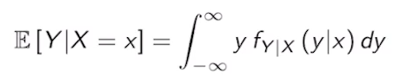
  - 關鍵特性：計算完成後，結果不再是一個常數，而是一個關於 x 的函數。這代表對於不同的 X 觀測值，我們會得到不同的 Y 預測值。
- 條件變異數 Var(Y|X=x)
  - 描述在已知 X 的情況下，Y繞其條件期望值的波動程度。
  - 同樣地，這也是一個關於 x 的函數。
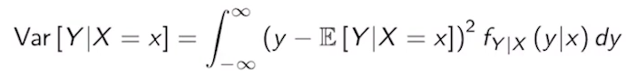

🛠️ 鋰電池製程的實際應用 (Lithium-ion Battery Context)
可以將這些統計工具應用於
- 共變異數 (Covariance)：你可以計算「攪拌轉速 (Speed)」與「漿料黏度 (Viscosity)」之間的共變異數。這能幫你量化兩者之間的聯動程度。
- 條件期望值 (Conditional Expectation)：當你想預測「如果攪拌時間是 60 分鐘，預期的漿料固含量 (Solid content) 是多少？」這就是在計算 E[Solid Content| Time = 60]。
- 條件變異數 (Conditional Variance)：這對於良率控制非常有用。例如，在「操作員 A」負責塗佈時，塗佈厚度的變異數 Var(Thickness | Operator = A) 是否比其他操作員更小？如果變異數較小，代表該操作員的穩定性更高。

▶️ Multiple Random Variables (5:46)
The first result we are going to cover in this video is what's called Bayes rule, so this is a very useful formula to reverse the order of the conditionals. We're going to start with the case of two discrete random variables X and Y. If you look at the equation below, the probability of y conditioned x is by definition the joint PMF p of x, y divided by the marginal p of x. You should notice that p of x given y is by definition p of xy divided by p of y. This implies that p of xy is equal to p of x given y times py which is exactly what we have used in this numerator. In the denominator, we're going to expand the marginal probability p of x, we start by looking at the joint PMF p of xy, taking values small x and small y. Remember that you can marginalize by summing over all possible ys in y, and this is equal to p of x, this is simply the rule of marginalization that we saw a few slides ago. Now, we can also write the joint PMF p of xy as p of x conditional y times p of y, which is exactly what we have in this expression here, also I should write that as a bar in there. For continuous random variables, we can apply the same formula, so in the numerator, we have the joint PDF divided by the marginal px. In the numerator, we get the same expansion as before, and in the denominator, we substitute the summation by an integral formula. Notice that in this formula, instead of y, I have used Theta in there but the same result would apply by calling that variable anything you want. So once you integrate over y doesn't matter what name you use for that variable. So far, our examples have been dealing with one or two random variables, in general, you can have a collection of n random variables that we call in here X_1 to X_n, had defined a random vector X so we're going to use the bold capital X to define a vector of random variables. Something we can do is we can essentially create a vector where each input is one of the random variables X_1 to X_n that were given at the beginning. We can define the mean of a random vector that we denote by E of bold X as the expectation of the vector, the expectation can move inside each one of the elements of this vector. Therefore, what we are going to obtain is that the expectation of a vector is a vector containing the expectation of each one of the random variables inside the vector. Similarly, for random vectors, we can define the covariance metrics, which is a metrics extension of the variance. This metrics that we denote by capital Sigma is going to be an n-by-n metrics and the ij entry of this metric Sigma that we can denote using these brackets is going to be nothing but the covariance between the random variable X_i and the random variable X_j. In here, I'm showing you the corners of this metrics. But in general, the ij entry of this matrix will be defined as we have in here. There is a particular case of multiple random variables that is very important, that is the multivariate Gaussian distribution. In that case, what we're going to have is n random variables, the mean of the vector of random variables that we denote by Mu is going to be an n-dimensional vector, and the covariance matrix is going to be an n-by-n matrix. If the random vector X is distributed according to a multivariate Gaussian, we'll use this notation, essentially the normal with this Mu and this covariance metrics. An explicit expression for that PDF is given by this convoluted formula. In the figure below, we have an example of a two-dimensional Gaussian, so essentially, we have in here x_1 and x_2, this is going to be the place of the PDF function in here, and the pink mesh in here represents the two-dimensional function that gives you the PDF of the normal distribution. We also have in blue, the projection of this PDF on x_1, so this is going to be the marginal, same story with this green curve in here, these are just the marginal, the projections of this two-dimensional distribution. With this video, we conclude our review of probability theory. Again, I suggest that you read the attached PDF that's included in the website to solidify some of the concepts I have covered in these videos. Now, we're going to move on to a review of the Python language. I would like to clarify that this is not a programming course, and we assume that you have some previous knowledge about programming. However, we will provide you with the tools to transition from whatever language you know into Python syntaxes. So I'll see you in the next video.
1 Attempt Quiz: Multiple Random Variables
這段影片標誌著機率論複習的終點，並帶入了三個在機器學習與工程數據分析中極其重要的工具：貝氏定理 (Bayes' Rule)、隨機向量 (Random Vectors) 以及 多元高斯分佈 (Multivariate Gaussian)。

1. 貝氏定理 (Bayes' Rule)：逆轉條件
貝氏定理的核心在於「當我們觀察到結果 X 時，如何回推原因 Y 的機率」。
- 公式結構：
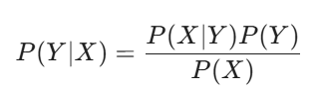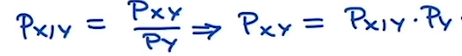
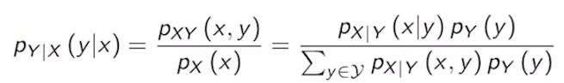
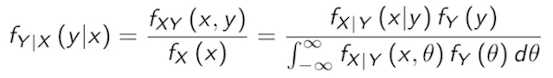
- 分母的展開：P(X) 通常透過全機率定理計算，即加總（或積分）所有可能的原因導致 X 發生的機率。
- 直覺意義：這能讓我們將「先驗知識 (Prior, P(Y))」結合「觀察到的數據證據 (Likelihood, P(X|Y))」，更新為「後驗機率 (Posterior, P(Y|X))」。

2. 隨機向量與共變異數矩陣 (Covariance Matrix)
當我們處理多個變數（例如電池的黏度、固含量、電導率）時，我們將其視為一個向量 random vector
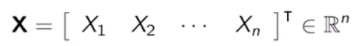
- 期望值向量 E[X]：就是各別變數期望值的集合。
- 共變異數矩陣 Sigma：這是一個 n x n 的矩陣，第 (i, j) 個位置代表第 i 個變數與第 j 個變數的共變異數。
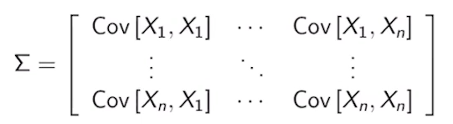
  - 對角線：代表各別變數的變異數 (σi^2)。
  - 非對角線：代表變數間的相關性。如果矩陣只有對角線有值，代表變數間互不相關。

3. 多元高斯分佈 (Multivariate Gaussian)
這是機器學習中最常使用的連續分佈，用來描述多個變數聯動的「鐘形面」。
- Multivariate Gaussian是一個重要的PDF, mean = µ (n-dimensional vector), covariance = Σ (nxn matrix)
- 邊際化 (Marginalization)：正如影片所提到的，如果你把二維高斯投影到單一軸（x_1 或 x_2），得到的依然是單變數的高斯分佈。
- 形狀由 σ 決定：
  - 如果 σ 是單位矩陣，等高線會是正圓形。
  - 如果變數間有相關性，等高線會變成傾斜的橢圓形。

一維 常態分佈 / 高斯分佈 Normal (µ, σ²)


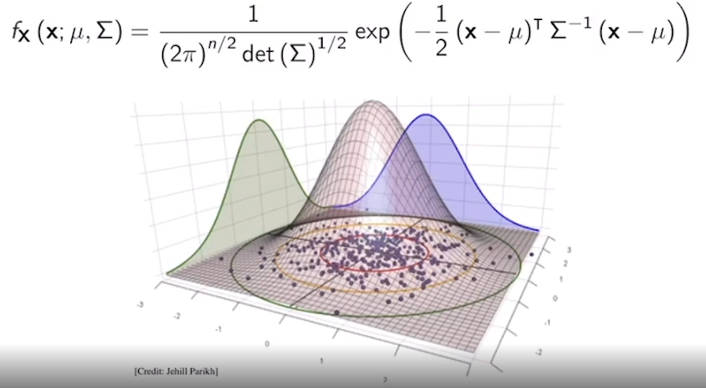
- 1. 核心數學公式 (The PDF Formula)
  - 圖片上方的公式描述了這張「鐘形面」的數學幾何形狀。
    - x：是一個包含兩個變數的向量，我們可以看作是底部的網格坐標 (x_1, x_2)。
    - µ (Mean Vector)：定義了圖中「鐘形頂峰」在底部網格上的投影位置，即數據分佈的中心。
    - Σ (Covariance Matrix)：這是最關鍵的參數。它決定了鐘形的「胖瘦」、「高矮」以及它是否「傾斜」（即變數間是否相關）。圖中底部網格上的傾斜橢圓形等高線，就是由 Σ 決定的。
- 2. 三維聯合 PDF 曲面 (3D Joint PDF Surface)
  - 圖中央那個淡粉色、立體的鐘形網格曲面，代表了 x_1 和 x_2 同時發生的機率密度。
  - 直觀理解：如果你在底部的散點圖上（代表觀測數據）統計某個區域內點的密度，越密集的地方，上面的曲面就越高。
  - 幾何特性：從公式中的 exp(…) 項可以看出，曲面的形狀由一個「二次型」(x-µ)^T Σ⁻¹ (x-µ) 決定。這意味著，如果你從水平方向截斷這個鐘形，截面會是一個橢圓形。
- 3. 底部的數據與等高線 (Bottom Plane with Data & Contours)
  - 底部的二維網格提供了直觀的數據分佈資訊：
    - 散點圖 (Scatter Plot)：那些紫色的點是從這個高斯分佈中隨機取樣出來的數據點。你可以看到點在中心處最密集，向四周擴散時變稀疏。
    - 橢圓形等高線 (Elliptical Contours)：紅色的圈圈連結了曲面上具有相同高度（相同機率密度）的點，並將其投影到底部。
    - Σ 的影響：你可以觀察到，這些橢圓的長軸並不是平行於 x 軸或 y 軸，而是傾斜的。這表明 x_1 和 x_2 之間存在正相關（當 x_1 增加時，Y 傾向於也增加）。 Σ 矩陣中的非對角線元素（Covariance）捕捉了這個特性。
- 4. 邊際分佈投影 (Marginal Projections)
  - 這是這張圖展示了「邊際化 (Marginalization)」的幾何意義：
    - 綠色曲線 (左側)：當我們把整個三維鐘形面朝著左側的平面「壓扁」或「投影」，就得到了 x_2 的邊際分佈。你可以把綠色曲線看作是把所有對應同一個 x_2 值的 x_1 機率加總（積分）的結果。這是一個單變數的高斯分佈。
    - 藍色曲線 (右側/後方)：同理，把鐘形面向後方的平面投影，就得到了 x_1 的邊際分佈。這同樣是一個單變數的高斯分佈。

💡 總結性直觀理解
這張圖告訴我們：多元高斯分佈是一個「由內而外」一致的優美結構。
- 「面」 (三維曲面) 描述了全局的聯合不確定性。
- 「線」 (底部等高線) 量化了變數間的聯動關係（Correlations）。
- 「影」 (綠色與藍色投影) 則分別描述了單一變數自身的統計特性，且它們依然保持高斯的形狀。

🛠️ 銜接你的背景：邁向 Python 模擬
既然你已經完成了機率論的複習，接下來進入 Python
- 貝氏定理的應用：在工廠診斷中，如果觀察到「塗佈厚度異常 (X)」，你可以用貝氏定理計算「機器故障 (Y_1)」或「材料變異 (Y_2)」的機率。
- Python 實作：在 Python 中，你會頻繁使用 NumPy 來處理這些向量和矩陣運算。例如，用 numpy.random.multivariate_normal 來產生模擬的生產數據。

Suppose I have two coins: one is a fair coin and the other is a biased coin that lands on Heads with probability ⅔. Assume that you randomly pick one of these two coins with equal probability and toss it. Given that it lands on Heads, what is the probability that you picked the fair coin? Enter your answer as an irreducible fraction.
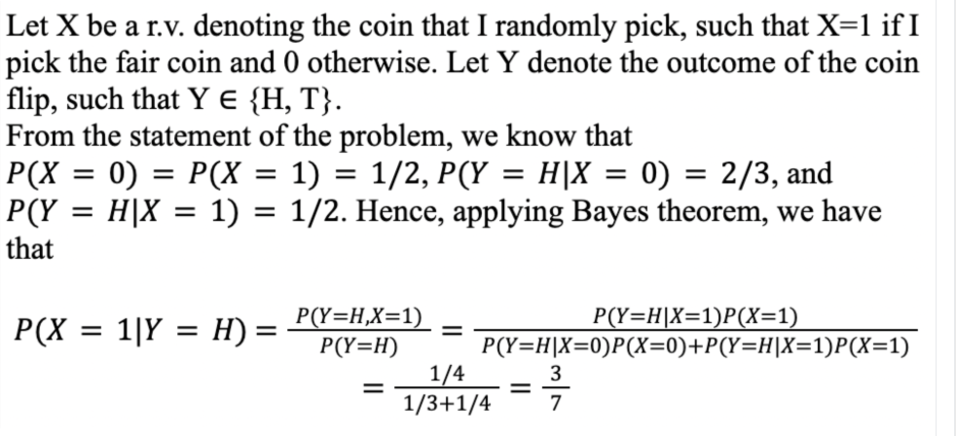
5. Python Lab
▶️ Python Introduction 1 (11:22)
Welcome back. In this course, we will use the Python language along with some standard set of numerical and data visualization tools to illustrate some of the techniques taught in this course. I would like to remark at this moment that this is not a programming course, and we are relying on your background on both probability and programming as a foundation for the topics that we will cover throughout this course. However, based on your previous programming experience, we will help you adapt to the Python programming language that has become one of the industry standards and most popular languages out there. To do so, we have prepared the document you have on the screen. This is a document in which we first showed you how to set up Jupyter Notebooks. As you can read in this document, there are two options to install and use Python in your computer. The first one is what's called the Anaconda distribution, which is a recommended option in this course. We also have a cloud-based option which is called Google Colab. So Anaconda is a free and open-source distribution of both Python and R and Google Colab, in contrast, is a free cloud service. Both supports running Jupyter Notebooks, which is the main programming environment we will use in here. The main difference is that if you choose the Anaconda option, the Notebooks will be executed locally in your own computer. In contrast, Google Colab will run in Google's Cloud servers. So if you use Google Colab, you will not be using your computing resources however, their program will run slower. Let's start with the Anaconda installation. To install Anaconda in your computer, you can follow the instructions in this link. So the link will take you to the Anaconda documentation where you can follow the instructions for installation for Windows, Mac, or whatever operating system you're using, as well as some of the requirements for installation. I would suggest that you read carefully, follow the instructions for your operating system, and install the appropriate software. Once you have installed Anaconda in your computer, you can open the Anaconda Navigator and launch Jupyter Notebook. The Anaconda Navigator will look like something in this screen, then you can go to Jupyter Notebook and launch it. This will open the Notebook dashboard that should look like the one on the screen. In here, you can open a new Python Notebook, just clicking in new, Python, and this will take you to an environment like the one in the screen, and in here you can run some piece of code, for example, you can run a Hello World program. To run the code in this cell, which is essentially the space in which you can write code, just press Shift and Return, and this will run the code inside the cell. So each one of these elements in here to the right of "In" brackets, is called a cell and you can run whatever piece of code you write in there just by clicking Shift, Return. In here, you have instructions to change the name of that piece of code, and run your own Hello World or Hello Anaconda code. You can also save the notebook by clicking the save icon or going to File, Save. So this is all quite self-explanatory. Now to close this Jupyter Notebook, make sure that you go to File, Close and Halt, and this will stop the Notebook and take you back to the dashboard. Now in here, you find several files. You can populate this environment by clicking Upload. I suggest that you populate this environment by uploading the files that we provide in this course. These files will be both Jupyter Notebooks that will have the extension IPYNB for Python notebooks, as well as some data files that will be typically in the form of text or CSV files. Once you upload these files, you can open, for example, the Jupyter Notebook for recitation 1. So click in here, and this will open the Jupyter Notebook associated with that first recitation. So in this first Jupyter Notebook, essentially, we provide you with an introduction to the syntaxes of the Python language. I will go through some of the most important points in here. I invite you to go carefully throughout the whole document to really get you up to speed with the Python language. I won't go through many of the cells in here since some of them are self explanatory but I will try to explain those that may be harder to understand. As you can see in this Notebook, we start with some basic operations. Essentially, this is a cell that includes a single comment. So essentially, whatever you have after the sharp sign, is a comment that will not be interpreted by the Jupyter language. So essentially, if I run this cell, nothing will happen. Now in the first cell, you can see that we have a few lines including some mathematical operations. For example, we can print 3 times 7, and this will produce 21. You can print 1 by 1, this will produce a 2, and you can bring 4.2 plus 5.8, and this will provide a 10. So I suggest that whenever you see these cells, just mess with them. Essentially, you can change, click Shift to return, and you will see how these evaluations change. So for example,1 plus 2, this will change to 3. So essentially, whatever you have in this cell will be printed below the cell after you press Shift and Enter. In the next cell, we have mode operations, we also have fancy operations in here. Python can also handle Boolean variables, so these Boolean variables will be represented by TRUE and FALSE capitalize. So make sure that you write things in a case sensitive manner. We also have standard comparisons, so the comparisons, for example, in equality make sure that you put the equality sign twice comparison operations. You can also chain comparisons and you can define variables using the single equality sign. So essentially we can define an inequality x equal to 2, y equal to 3 and we can print the sum of those two variables. Notice that we are not including type, in the definition of the variables, because Python is dynamically typed. So Python will automatically assign a type according to what you put in the right-hand side. Also, since Python is a dynamically typed, we can change the type through operations, so for example, you can print the type of x that will define above and this should be an integer because x is equal to 2. Now, if we change x to 2.5 and we print the type again, we should get a floating number, so if we run this is going to be a floating number. We can now move on to type some functions, so we start by looking at strings. So strings are going to be delimited by either single, or double quotations, we can use len of whatever string you put in the argument, to measure the length of the string. Also, we can use backslashes to denote special characters. If for whatever reasons you need to count the tabulation as a character, you can just use r to create a raw string in which backlash is considered a character itself. You can also create multiline strings, using triple quotes.
You can format simple strings so I invite you to read this particular cell to know how to include text inside the strings. Also, something that's important is at least in Python, are not restricted to contain a single type. So for example, you can define a list including integers alone, but you can have a heterogeneous list where you can have tags, numbers, and Boolean variables. You can also go one step forward and generate a list of lists.
Something that's very useful is to generate the range list. So essentially if you want to generate a list of numbers from zero to some value x minus 1, you can use this particular line of code. So essentially this will generate a list, starting at zero and ending at 10 minus 1 meaning nine. So if you print x, you will get the list 0-9, which is what you have in this first line. To access the elements inside this list, you can use the square brackets, for example x at zero will be the first element of the list, x at one will be the second element of the list. Notice that the indexes in Python start at zero. So the zeroth element will be the first element in the list and the n minus 1 index will indicate the nth element in the list. You can also index element backwards so essentially, the minus one element in the list, is the last one and then minus two will be the second to last. Also, lists are mutable, meaning you can change their content. So if you have x at the first entry, equal to minus one, you're essentially changing the list to include the element minus one in the first entry. So if we print x at zero, we'll get a minus one, If we print the list x, you will observe that the first element that before was zero, now is a minus one. You can also use colon notation, to slice a list, you can also use the in operator, to check if a particular element is in a list. You can also concatenate lists, by using extend, you can also use plus to concatenate lists, but you will not change the content of the variable y. You can also use append to add a single element to the list. Also if you're unpacking a particular list and you don't care about one of the entries of the list, you can just use the underscore symbol to discard that variable.
Also, notice that strings are arrays of characters, so all the operations that we described above, meaning indexing entries while slicing a list, are applied to strings.
So this finalizes our first week of lectures, we started by going over the list of topics to be covered in this course, as well as some administrative details. Then we moved on, to a series of videos reviewing probability theory, which as I mentioned before it is a very important part of this course and we wrapped up by providing an introduction to the Python language. Next week, we'll move on to the foundations of statistical learning theory. I'll see you next week.
Week 1 Extra Resources

